

**Preparatory data Structure (CSCI 591)**



**Implementing a linked list with Recursive Function**

**Project - V**

**March 3, 2020**

**St. Cloud state university**

**Department of Computer Science**

Submitted By: Taddese Erba

# **Design Document**

## **Introduction**

A linked list is a linear data structure of objects that are stored at random memory locations and linked together by pointers. Like any other function, linked lists’ operations can be implemented recursively. This project sought to implement linked lists using recursive functions.

This project will implement the methods and operations of Project Three using recursive functions wherever it applies. The project contains three distinctive files; the header file list.h, the implementation file list.cpp, and the test file main.cpp implementation file contains all the implementation for the classes. The main.cpp.

## **Data Structure**

As briefly described in the introduction section of this document, this program has three distinct files. The list.h file contains all the declaration of the required functions and a few function decoration (implementation). It is the framework for LinkedList class implementation. It consists of nine private objects, the struct Node object which is used to lold the two main components of a node, the Node * getNode(Item entry, Node * list) function used to declare and initialize the nodes. The implementation of this function does not require recursive operation as it does not involve any looping. The other seven functions that declare the recursive functions for corresponding operations. In addition to the nine private objects, the header file contains twelve public functions which include two constructors, one destructor, eight operational functions, and one friend function.

## **Functions**

As described in the Data Structure section of this document, there are twenty-one functions in this project. The first two functions, the LinkedList() and LinkedList(const LinkedList& source) are constructors. The LinkedList()constructor function is used to initialize the class. The constructor LinkedList(const LinkedList& source) is a copy constructor that is used to copy the elements of the list. The function void copyNew(const LinkedList& mynew) implements the copy constructor recursively along with the function void copy(Node*& source, Node * ptr). The third function, ~ LinkedList(), is a destructor. It is used to delete all the nodes, deallocate the memory, and return it to the operating system. The void re_Initialize() function is used to re-initialize the linked lists to empty. This function is implemented non-recursively. The void insert(Item entry) along with the function void rec_Insert(Item entry, Node*&p) is used for the recursive implementation of the insert operation. The void remove(Item target) along with the function void rec_Remove(Item target, Node*&p) is used to recursively remove a node from the list. The void operator = (LinkedList s) is used to overload the assignment operator (=) to be used in the assignment operation involving copying the elements of the list. The bool isEmpty() function returns true if the list is empty or false otherwise. The int listLength() function together with int length(Node * p) will count each node in the list recursively and return the size of the list (number of nodes). The bool isPresent(Item target) will check if an item is in the list recursively using the recursive function bool Present(Node*ptr, Item found) and returns true if the target is found. If the item is not found it returns false to main(). The Item kthValue(int numval) function will return the kth node of the list. If the node is not found, or the list is empty, it returns nothing. The friend ostream& operator << (ostream& out_s, const LinkedList& l) is a friend function that is used to overload the outstream operator (<<) for the purpose of printing all the elements of the list. It is implemented recursively and functions jointly with the recursive part void LinkedList::write(ostream& out_s, Node*p). For convenience reasons, the friend function, along with its recursive counterpart, is implemented in the header file where it was declared but outside of the class LinkedList.

## **The Main Program**

As a testing function, where the implementation is tested, there are many things going on in the main() function. To keep things simple, I will talk only about the main components of the main() function. The key frameworks in the main() function are the instantiation of the class LinkedList and representation of the key operations by a menu system. There are ten main menus from which the user can choose to perform an operation. The menus are represented by alphabets that are closely related to the operation followed by the name of the operation as in ***I -- Insert Item*** and ***R -- Remove Item***. The menus are continuously displayed after each operation until the user chooses to quit the program. A switch statement will track each choice of the user and perform the necessary operation accordingly. It may also worth mentioning the bool searchArray(const char [], int, char) function that is the part of the main() function that is used to search the array of constants that hold the alphabets designated to the menu. This enables that if the user enters a choice that is not available, the program can display the necessary message and exit the program.

# **Code listing**

## **The header file (List.h)**

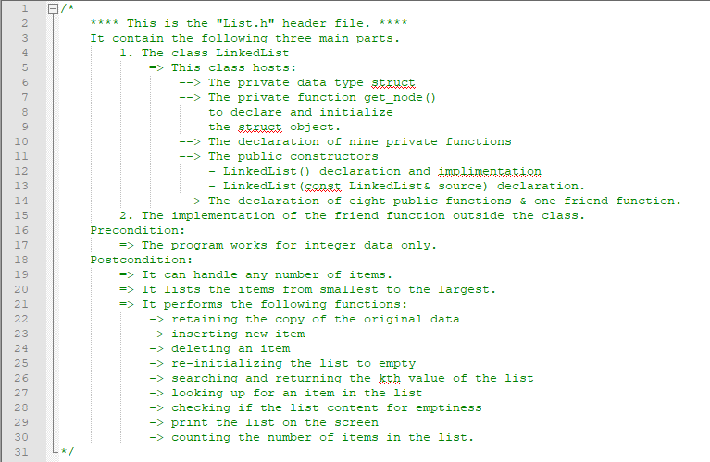

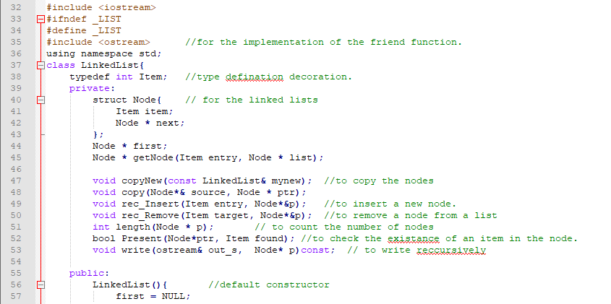

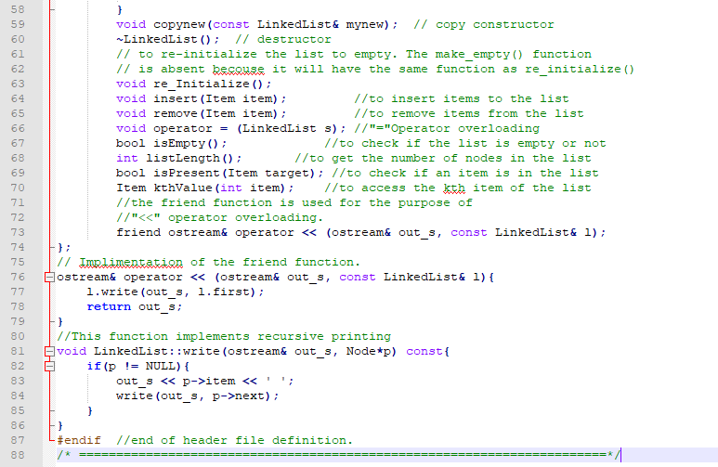

## **The implementation file (List.cpp)**

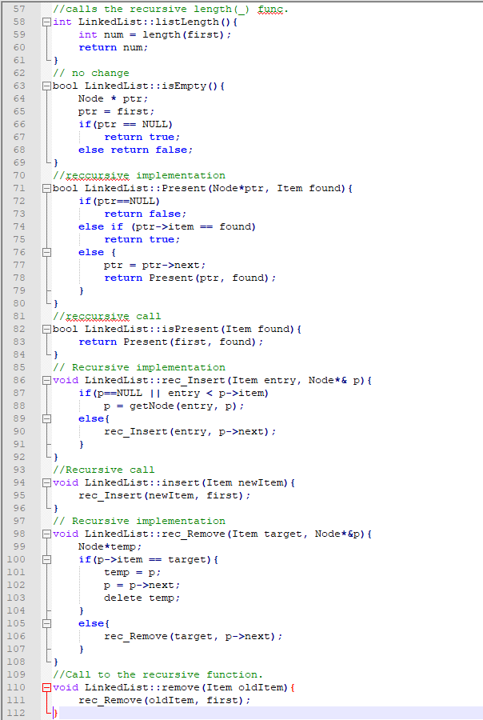

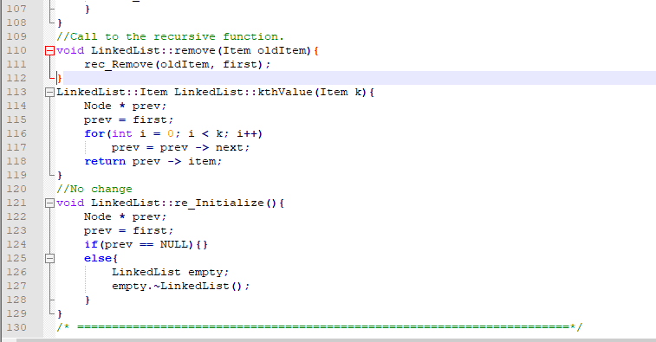

## **The testing file (main.cpp)**

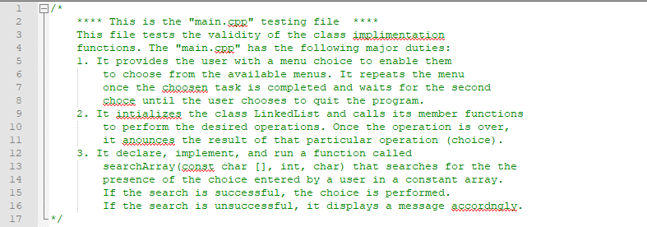

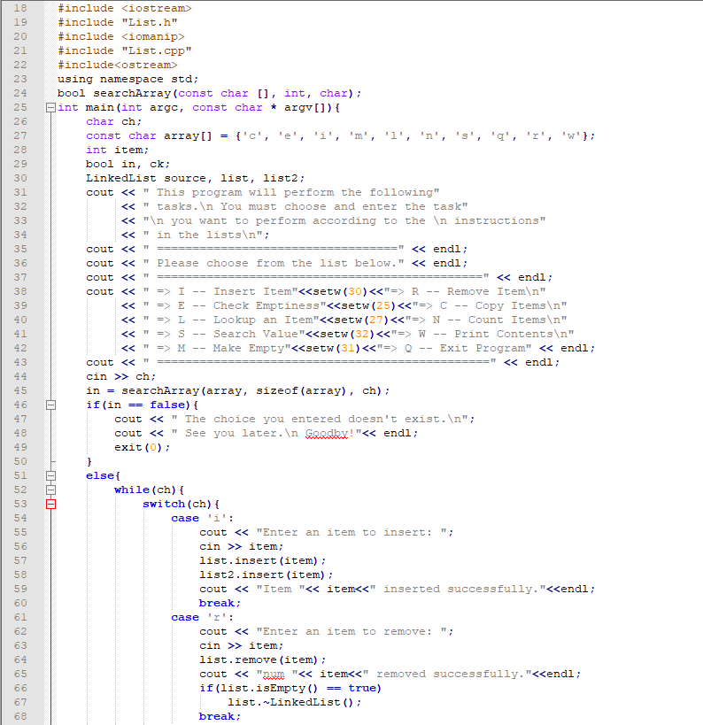

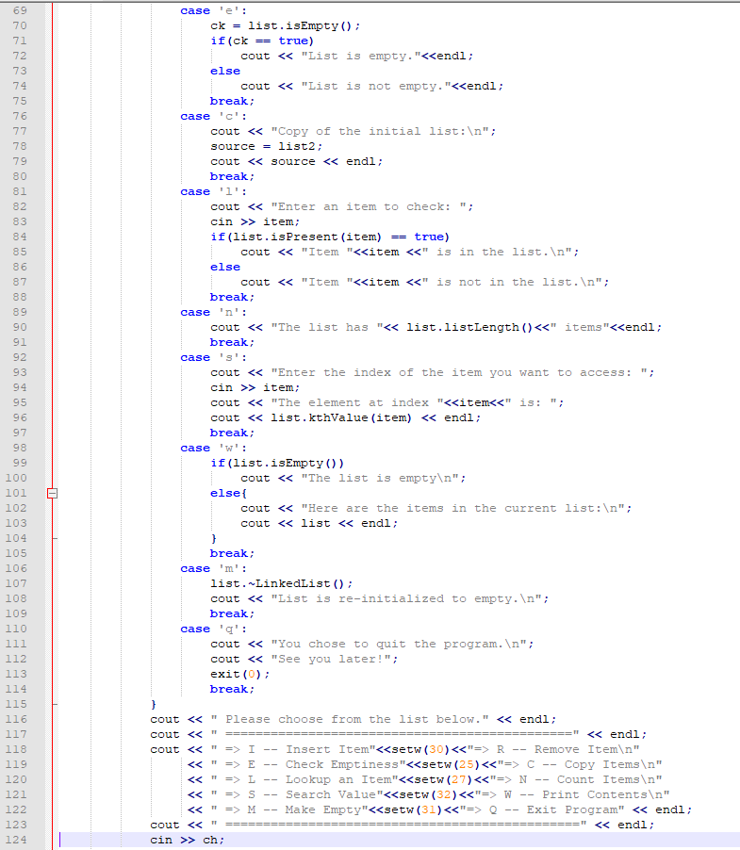

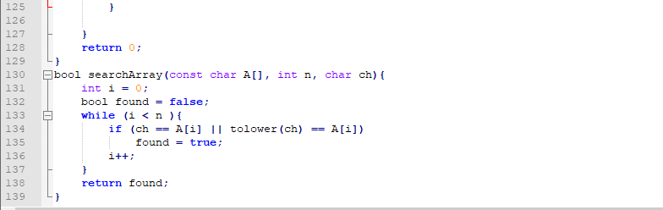

# **Test Results**

**Display befor the tests.**

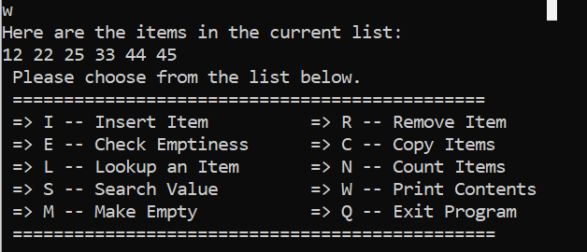

## **Tests result for insert() function.**

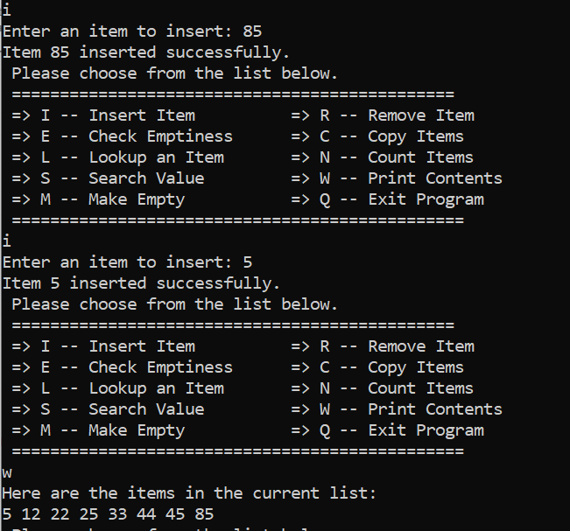

## **Tests result for remove() function.**

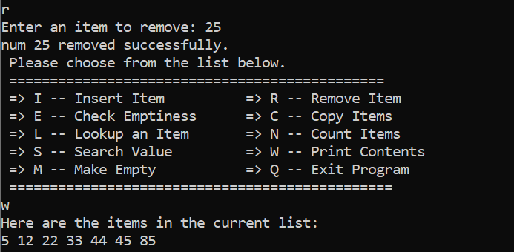

## **Tests result for copy () function.**

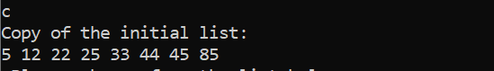

## **Tests result for isPresent() function.**

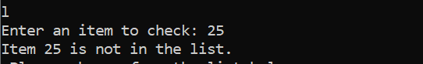

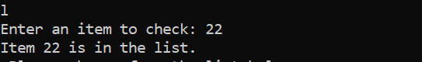

## **Tests result for listLength() function.**



## **Tests result for kthValue() function.**

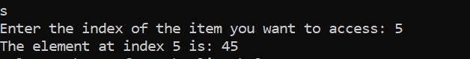

***Note***: If we try to access an index that is not in the list the function will exhaust searching that index and exit the program as shown in the above screenshot.

## **Tests result for write () function**

I am not running a separate test for the write () function since I am running it for almost every other step as part of checking the program to see if it is doing what it supposed to do. Please look at the end of the other programs where I occasionally run the write() function.

## **Tests result for checkEmpty () function**



## **Tests result for makeEmpty () function**





## **Tests result for quit**

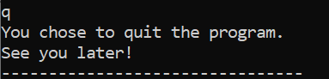

Moreover, if the user enters a choice that is not listed the program will announce that and exit as shown below.

# **User document**

This program can perform different tasks on a linked list as shown in the menu below. In order to run the program, you must perform the following steps.

* The program name is main.cpp. on the terminal enter the following command to compile and run the program.

g++ -o main main.cpp

* The program will compile and open the following window:

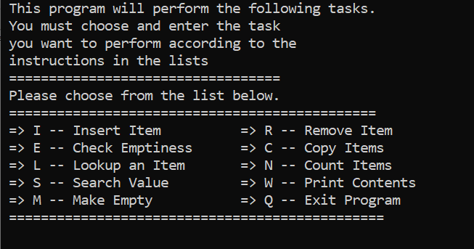

* Once the window opens, make a choice from the displayed menu. For example to insert an item type i or I and then enter.

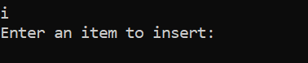

* Next, type the item you want to insert and then enter. For example, type 15 and enter.

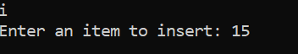

* The program will announce that the item is entered successfully and display the menu to make the next choice.

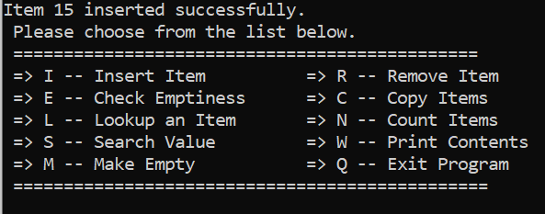

* If you want to repeat the insert repeat the above procedure; otherwise make the next selection.
* The program will perform in the same manner for all other tasks as for insert. Hence, all the other eight functions will perform in the same manner.
* Feel free to play around with the other choices (alphabets) and see what the program is meant to do.
* If you wish to exit the program, type q (Q) and enter.

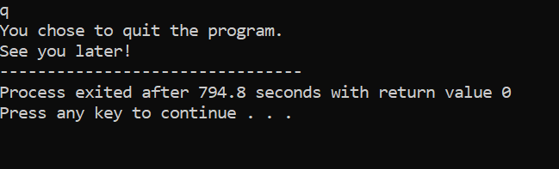

* Now you can close the window.

Here are very important points while using this program

1. You must insert integer values only. If you try to enter something else other than an integer, the program may crash.
2. Do not try to access the ends of the list. If your list has 3 nodes only and you try to access the 4th node, the program will stop and exit.
3. The program will save a copy of the current list you are working with. You can just type c(C) and access that copy. Of course, once you exit the program that copy will not exits.

# **Summery**

The project implements linked list operations such as inserting a new item, removing an item from the list, making the list empty, checking for the presence of an item, displaying a copy of the original item that contains all the elements of the list and so on recursively where every recursion can apply. This project applies the knowledge I gained from the lecture presented in the classroom and the knowledge I gained from reading different C++ data structure books.

This program can be made more useful by making it accommodate various types of data such as strings, characters, and double variables. This way, the program can do something important such as storing important records. Furthermore, data could also be made available as a file and a permanent copy of that file is kept with all current updates included while we still have the old data for reference.

By completing this project, I have gained a significant level of confidence and the necessary knowledge to work with linked lists and recursive function implementations. The only challenge I faced while completing this project is how to implement the recursive function for the out streaming function which I finally figured out how to do it. [1]

1. This materials in this document is mostly from the previous project due to the close similarity of the two projects.